Linked list data structure in c++
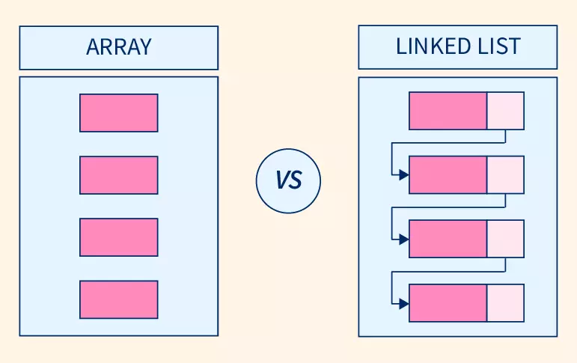

Array:Arrays store elements in contiguous memory locations, resulting in easily calculable addresses for the elements stored and this allows faster access to an element at a specific index.
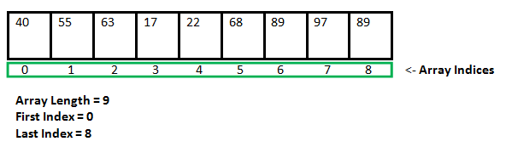

Linked List:Linked lists are less rigid in their storage structure and elements are usually not stored in contiguous locations, hence they need to be stored with additional tags giving a reference to the next element.

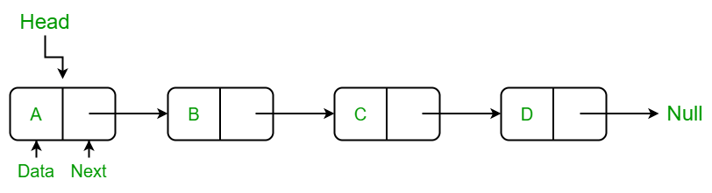

Every Node store Value + Location of next node in linked list, here all node linked with each other using pointer / location so known as “linked” List. Easy to insert and remove element from list just need to change link between node, this is very costly in case of ARRAY.

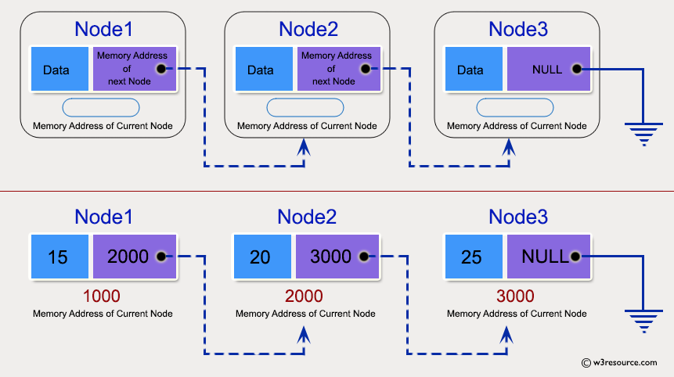

First element from list identify using Head pointer and last element of NODE contains NULL pointer indicates end of list.

Note: Linked list is not built in type data structure, so we will have to create this if we want to use inside our code.
Linked list is user define datatype.Need to make related class and method if want to use it insid code.

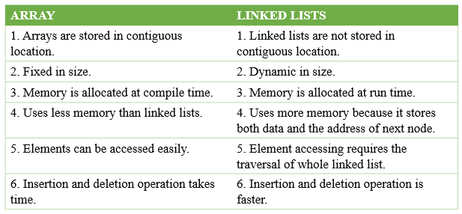

CODE:
//Linked list - Every node contains value + Location of the next node
//Easy to ADD / Remove element not rigid fix size structre like Array.
//Linked list is user define datatype,need to necessary class and method for operations.
//Jaydeep Shah

#include<iostream>
using namespace std;

//Create class "NODE" for storing value + ADD of next node
class NODE
{
public:
int data; //value of data
NODE* next; //ADDRESS of next node

//make constructor so during creating node object we can assign value and address of next node.

NODE(int value)
{
data = value;
next = NULL; //initially null pointer act as last element of list
}

};

//------------------------------------------------------------
//Create method/function for updating linked list
//Two Parameter as a argument required: 1)Value 2)Head Node
void insert_at_tail(NODE* &head,int value)
{
//1]
//Create temp node for storing argument value
//This node need to place on Heap,otherwise memory will be erase after complition of function call
NODE* temp = new NODE(value); //We have temp node with user value

//2]
//If no any list created in past and passed element is first one
if(head == NULL)
{
head = temp;
return;
}

//3]
//Make local variable for furthe process
NODE *test = head;

//4] Finding last element inside list
while(test->next != NULL)
{
test = test->next; //Iterator
}

//5]Link list
test->next = temp;

cout << endl << "Sucessfully element added in tail";
}
//------------------------------------------------------------

//------------------------------------------------------------
//For printing linked list
void print_link(NODE *p)
{
NODE *temp = p;
cout<< endl << "List print : ";
while(temp->next != NULL)
{
//PRINT current element
cout << temp->data << " , ";
//Update for next node
temp = temp->next;

}
}
//------------------------------------------------------------

int main()
{
//Create null pointer act as HEAD
NODE *user = NULL;

//Insert value in list
insert_at_tail(user,1);
insert_at_tail(user,2);
insert_at_tail(user,3);
insert_at_tail(user,4);
insert_at_tail(user,5);

//print list
print_link(user);

return 0;
}

OUTPUT:
